

**MGM’s POLYTECHNIC, AURANGABAD**

**2020-2021**

Micro Project Report

On

**Report on Construction of foil semiconductors and wire wound strain gauge**

Submitted in partial fulfilment for ‘I’ Scheme fourth semester of

# Diploma in

# MECHANICAL ENGINEERING

# By

Dhakne Ramakant Mahendra (1915010275)

Mohammed Saad Sayyed (1915010276)

Jadhav Swaraj Milind (1915010277)

Under the guidance of

# Prof. Guide Name M.S Jadhav

(Lecturer in Mechanical Engineering)

***In Pursuit of Excellence***



[**Maharashtra State Board of Technical Education, Mumbai**](http://msbte.org.in/)**(Autonomous) (ISO-9001-2008) (ISO/IEC 27001:2013)**



**Maharashtra State**

**Board of Technical Education, Mumbai**

**Certificate of Completion**

This is to certify that Mr .**Dhakne** **Ramakant Mahendra, Mohammed Saad Sayyed, Jadhav Swaraj Milind** .with Enrollment No **1915010275, 1915010276, 1915010277,** has successfully completed his/her Micro-Project entitled **"** Report on **" Construction of foil semiconductors and wire wound strain gauge** in the Course/Subject of **" "**in the fourth semester during his/her tenure of completing the Diploma programme in **Mechanical** **Engineering** From

**MGM's Polytechnic** institute with institute code **1501.**

**Guide HOD**

# M.S Jadhav Bhalekar B.D

Mechanical Engineering **Principal**  Mechanical Engineering

Dr .B.M. Patil

# ACKNOWLEDGEMENT

We would like to express my/our gratitude towards guide **Prof. M.S Jadhav** for the useful comments, remarks and for giving his/her valuable guidance and inspiration throughout the learning process of this report.

Furthermore, We would like to thank our **Prof. B. D. Bhalekar (HOD)** for making available all the facilities for the successful completion of this work and other staff members of **Mechanical Engineering Department** for their valuable help.

It is with humble gratitude & sense of indebtedness, I/we thank my respected and esteemed **Dr. B. M. Patil (Principal)** for his valuable guidance, suggestion and constant support which lead towards successful completion of this work.

**Date: / / 2020**

**Place: Aurangabad**

**Student Name (Enrollment No: 123)**

**Chapter 1**

**Introduction**

wire-strain gaugea device that consists of a fine **wire** firmly bonded to thin paper and that when attached to an object subjected to stress indicates minute changes in **strain** by corresponding changes in electrical resistance of the **wire** as it is likewise elongated.

A strain gauge is an example of a passive transducer that converts a mechanical displacement into a change of resistance. It is a thin, wafer-like device that can be attached to a variety of materials by a suitable adhesive to measure the applied strain.

As the structure is stressed, the resulting strain deforms the strain gauge attached to the structure. It causes an increase in the resistivity of the gauge which produces an electrical signal proportional to the deformation.

The strain gauge displacement sensor consists of a structure attached with the strain gauge that elastically deforms when subjected to a displacement

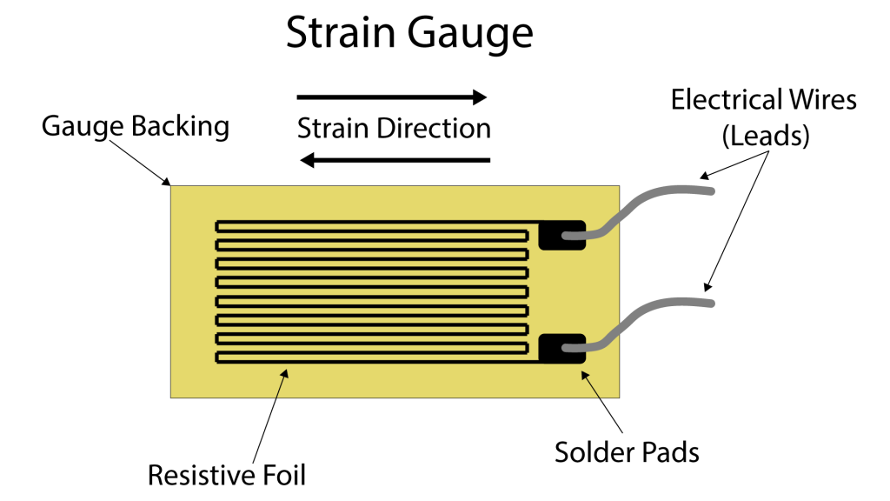

**Chapter 2**

**Function of strain gauge**

A Strain gauge is a sensor whose resistance varies with applied force; It converts force, pressure, tension, weight, etc., into a change in electrical resistance which can then be measured. When external forces are applied to a stationary object, stress and strain are the result. Stress is defined as the object's internal resisting forces, and strain is defined as the displacement and deformation that occur.  
  
The strain gauge is one of the most important sensor of the electrical measurement technique applied to the measurement of mechanical quantities. As their name indicates, they are used for the measurement of strain. As a technical term "strain" consists of tensile and compressive strain, distinguished by a positive or negative sign. Thus, strain gauges can be used to pick up expansion as well as contraction.

The strain of a body is always caused by an external influence or an internal effect. Strain might be caused by forces, pressures, moments, heat, structural changes of the material and the like. If certain conditions are fulfilled, the amount or the value of the influencing quantity can be derived from the measured strain value. In experimental stress analysis this feature is widely used. Experimental stress analysis uses the strain values measured on the surface of a specimen, or structural part, to state the stress in the material and also to predict its safety and endurance. Special transducers can be designed for the measurement of forces or other derived quantities, e.g., moments, pressures, accelerations, displacements, vibrations and others. The transducer generally contains a pressure sensitive diaphragm with strain gauges bonded to it.

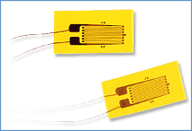

**Chapter-3**

**Strain Gauge Working Principle**

The foil type strain gauges (Figure 1) are very common in which a resistive foil is mounted on a backing material. These are available in a variety of shapes and sizes for different applications. The resistance of the foil changes as the material to which the gauge is attached undergoes tension or compression due to change in its length and diameter.  
   
This change in resistance is proportional to the applied strain. As this change in resistance is very small in magnitude so its effect can be only sensed by a Wheatstone bridge. This is the basic strain gauge working principle.

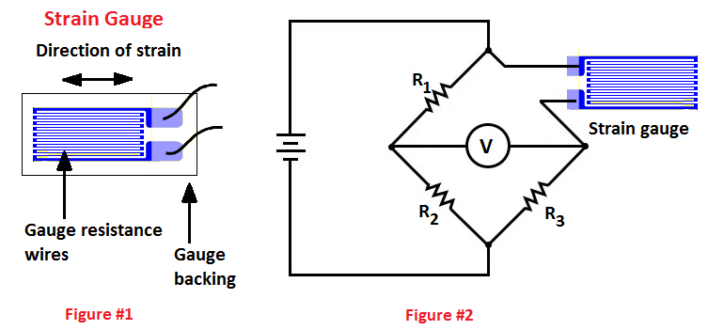

A circuit diagram is shown in Figure 2. In this circuit diagram, a strain gauge is connected into a Wheatstone bridge. This circuit is so designed that when no force is applied to the strain gauge, R1 is equal to R2 and the resistance of the strain gauge is equal to R3. In this condition the Wheatstone bridge is balanced and the voltmeter shows no deflection.

## But when strain is applied to the strain gauge, the resistance of the strain gauge sensor changes, the Wheatstone bridge becomes unbalanced, a current flows through the voltmeter. Since the net change in the resistance is proportional to the applied strain, therefore, resultant current flow through the voltmeter is proportional to the applied strain. So, the voltmeter can be calibrated in terms of strain or force

## **Chapter 4**

## There are four main parts of **Strain Gauges**

1. Wire wounded strain gauges

2. Foil type strain gauge

3. Semiconductor strain gauges

4. Capacitive strain gauges

1. Wire wounded strain gauges: In an electrical resistance strain gauge, the device consists of a thin wire placed on a flexible paper tissue and is attached to a variety of materials to measure the strain of the material. This change in resistance is proportional to the strain and is measured using a Wheatstone bridge.

There are two main classes of wire wound strain gauges

: ➢ Bonded strain gauge

➢ Unbonded strain gauge

**Bonded strain gauge**: These gauges are directly bonded (that is pasted) on the surface of the structure under study. Hence they are termed as bonded strain gauges. Along with the construction of transducers, a bonded metal wire strain gauge is used for stress analysis. A resistance wire strain gauge has a wire of diameter 0.25mm or less.

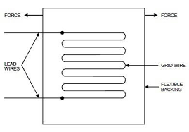

The grid of fine resistance wire is cemented to carrier. It can be a thin sheet of paper, Bakelite or a sheet of Teflon. To prevent the wire from any mechanical damage, it is covered on top with a thin sheet of material. The spreading of wire allows us to have a uniform distribution of stress over the grid. The carrier is bonded with an adhesive material. Due to this, a good transfer of strain from carrier to a grid of wires is achieved.

A resistance wire strain gauge must possess the following characteristics in order to have desirable results

1. The strain gauge should have a high value of gauge factor. As high gauge factor indicates a large change in resistance, which leads to high sensitivity.

2. The gauge resistance should be high so as to minimize the effect of undesirable variations of resistance in measurement circuits.

Typically, the resistance of strain gauges is 120Ω, 350Ω, 1000Ω. But a high resistance value results in lower sensitivity. Thus to have higher sensitivity, higher bridge voltages have to be used.

• The strain gauge should have low resistance temperature coefficient.

• It should possess linear characteristics in order to have the constancy of calibration over its entire range.

• Strain gauges must have a good frequency response. The linearity should be maintained within accuracy limits.

* **Various types of bonded strain gauges are**

: 1. Grid type:

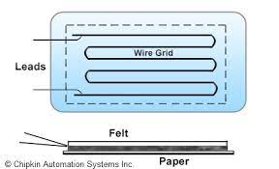

2. Rossette type: If the axis of the strain in a component is unknown, Strain Gauge Transducer Types may be used to determine the exact direction. The standard procedure is to place several gauges at a point on the member’s surface, with known angles between them. The magnitude of strain in each individual gauge is measured, and used in the geometrical determination of the strain in the member. Shows a three-element strain gauge, called a Rossette gauge, in which the angle between any two longitudinal gauge axes is 45°.

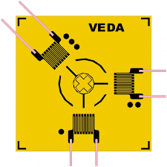

3. Torque type:

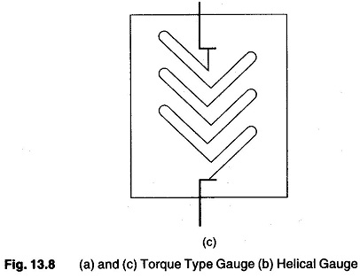

4. Helical type:

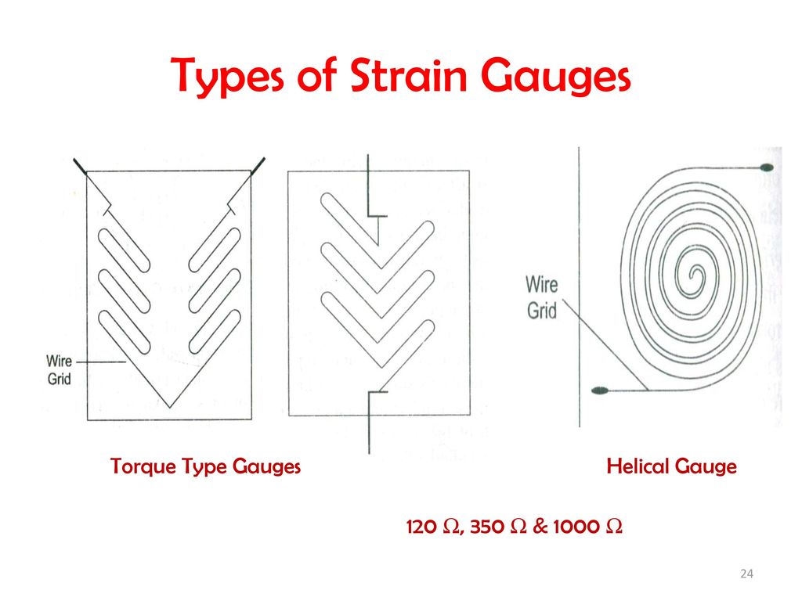

Unbonded strain gauge:

It is a type of gauge in which a wire is stretched in an insulating medium in between two points. The insulating medium can be air. The wire can be made of alloys such as copper-nickel, chrome nickel, nickel-iron having a diameter of about 0.003 mm. The gauge factor for this category of the strain gauge is about 2 to 4 and capable to withstand a force of 2MN. These are almost exclusively used in transducer applications where preloaded resistance wires are connected in a Wheatstone bridge configuration. The arrangement of unbonded strain gauges consists of the following. Two frames P and Q carrying rigidly fixed insulated pins as shown in diagram. These two frames can move relative with respect to each other and they are held together by a spring loaded mechanism. A fine wire resistance strain gauge is stretched around the insulated pins. The strain gauge is connected to a wheat stone bridge.

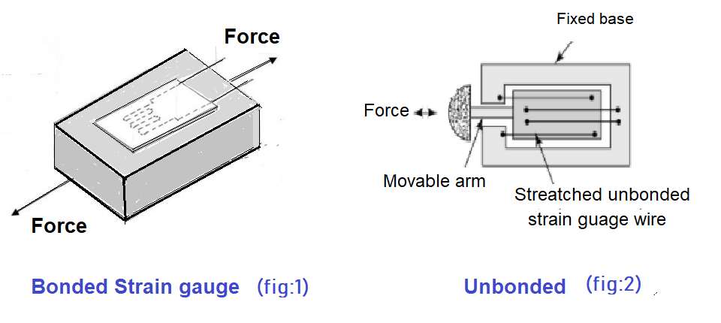

**Operation of Unbonded strain gauges**:

When a force is applied on the structure under study (frames P & Q), frames P moves relative to frame Q, and due to this strain gauge will change in length and cross section. That is, the strain gauge is strained. This strain changes the resistance of the strain gauge and this change in resistance of the strain gauge is measured using a wheat stone bridge. This change in resistance when calibrated becomes a measure of the applied force and change in dimensions of the structure under study.

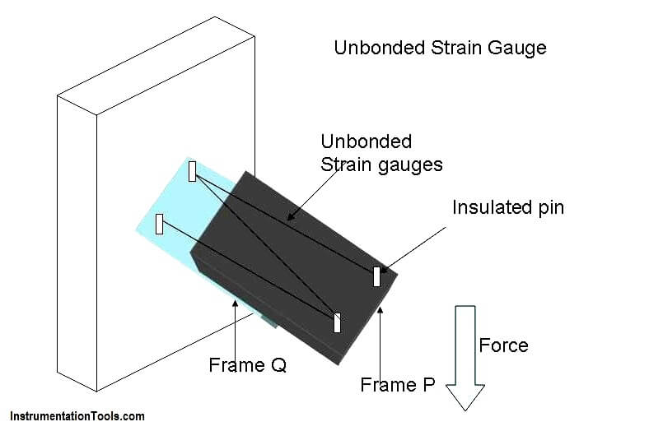

Application of Unbonded strain gauge:

Unbonded strain gauge is used in places where the gauge is to be detached and used again and again. unbonded strain gauges are used in force, pressure and acceleration measurement.

Advantages of Unbonded strain gauge:

The range of this gauge is +/- 0.15% strain. This gauge has a very high accuracy.

Limitation of unbonded strain gauges It occupies more space.

**Foil Strain Gauge:**

This is an extension of the resistance wire strain gauge. The strain is sensed with the help of a metal foil. The metals and alloys used for the foil and wire are nichrome, constantan (Ni + Cu), isoelastic (Ni + Cr + Mo), nickel and platinum. Foil gauges have a much greater dissipation capacity than wire wound gauges, on account of their larger surface area for the same volume. For this reason, they can be used for a higher operating temperature range. Also, the large surface area of foil gauges leads to better bonding. Foil type Strain Gauge Transducer Types have similar characteristics to wire strain gauges. Their gauge factors are typically the same. The advantage of foil type Strain Gauge Transducer Types is that they can be fabricated on a large scale, and in any shape. The foil can also be etched on a carrier. Etched foil gauge construction consists of first bonding a layer of strain sensitive material to a thin sheet of paper or bakelite. The portion of the metal to be used as the wire element is covered with appropriate masking material, and an etching solution is applied to the unit. The solution removes that portion of the metal which is not masked, leaving the desired grid structure intact



This method of construction enables etched foil strain gauges to be made thinner than comparable wire units, this characteristics, together with a greater degree of flexibility, allows the etched foil to be mounted in more remote and restricted places and on a wide range of curved surfaces. The longitudinal sensitivity of the foil gauge is approximately 5% greater than that of similar wire elements.. The resistance value of commercially available foil gauges is between 50 and 1000 Ω the resistance films are vacuum coated with ceramic film and deposited on a plastic backing for insulation

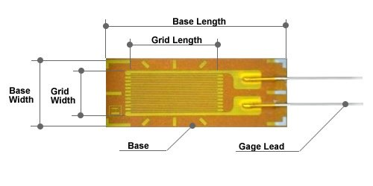

**Semiconductor Strain Gauge:**

Semiconductor strain gauges are used when a very high gauge factor is required. They have a gauge factor 50 times as high as wire strain gauges. The resistance of the semiconductor changes with change in applied strain to have a high sensitivity, a high value of gauge factor is desirable. A high gauge factor means relatively higher change in resistance, which can be easily measured with a good degree of accuracy. Semiconductor strain gauges depend for their action upon the piezo resistive effect, i.e. change in value of the resistance due to change in resistivity, unlike metallic gauges where change in resistance is mainly due to the change in dimension when strained. Semiconductor materials such as germanium and silicon are used as resistive materials. A typical strain gauge consists of a strain material and leads that are placed in a protective box, Semiconductor wafer or filaments which have a thickness of 0.05 mm are used. They are bonded on suitable insulating substrates, such as Teflon

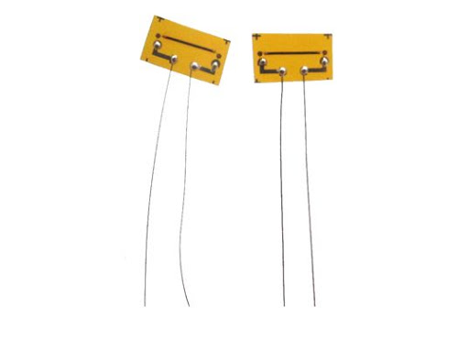

**Chapter 5**

**Advantages of Strain Gauge:**

1. There is no moving part and hence no wear
2. Strain gauges are very precise
3. It is small and inexpensive
4. It has a high-frequency bandwidth.
5. Testing ships hulls.
6. Vehicle testing **applications**.

**Disadvantages of Strain Gauge**

1. It is non-linear
2. It is very sensitive to temperature.
3. It needs to be calibrated regularly
4. Strain gauges have to be applied manually. Putting them in their place consuming and costly. It is one of their biggest disadvantages
5. Strong output signal

**Chapter 6**

## **Strain Gauge applications**

**Aerospace Applications** – strain gauges are bonded to load-bearing components within air crafts to measure any strain and stress which takes place within various areas during flight. Strain gauges can monitor the wing deflection or deformation during flight to ensure it is safe. They also monitor various on-board units and power supplies.

**Rail applications** – strain gauges can be bonded to the railway lines themselves to monitor and measure the stress the lines are under. The readings they produce can alert personnel if the railways become under too much stress or strain. This ensures the railway line stays safe to use and allows repairs and maintenance to be carried out before any visible signs of strain or stress show.

**Use within Load Cells** – strain gauges are used within load cells, the measure the strain and stress the load cell is under to determine weight and quantities. They can also be incorporated into other sensors including pressure transducers to help with pressure measuring.

**Measuring stress on circuit boards** – some very small strain gauges can measure stress on electric circuit boards and other confined spaces.

**Residual Stress monitoring** – this is a very broad term and can refer to monitoring stress in casting, welding and formation processes during manufacturing. This is a common application for strain gauges. They can also be used to monitor stress during high speed drilling applications.

Other applications;

* Testing ships hulls
* Vehicle testing applications
* Structural component testing
* Construction applications

**Chapter 7**

**Conclusion**

Strain gauges are profoundly versatile geotechnical tools with very broad applications that help to ensure safety and productivity. They are especially prized for their precision, ease of installation, low cost, long operating life, and the need for very limited maintenance. It is exciting to consider the many future applications of strain gauges in fields such as aerospace, cable bridges, rail monitoring (for railroad systems), and measuring torque and power in a wide range of rotating equipment such as fans, generators, wheels and propellers.

I hope this post helped you to better understand the different types of strain gauges, how they work, and their applications

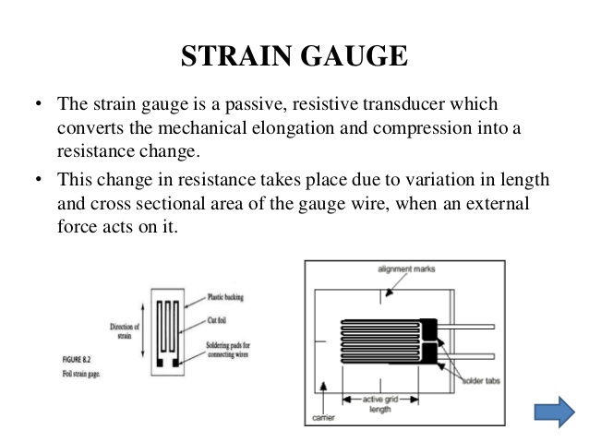

**Chapter 8**

## **Characteristics of Strain Gauges**

:

* It should have a high value of gauge factor. With the high value of the gauge factor, we can get a high sensitivity of the system.
* It should have a high value of resistance as it minimizes the effect of unwanted variations of resistance in the measurement circuit.
* It should have low resistance temperature coefficient. It is very necessary to minimize errors due to temperature variations.
* It should not have any [hysteresis effects](https://www.yourelectricalguide.com/2019/04/types-errors-transducers.html).
* It should have [linear characteristics](https://www.yourelectricalguide.com/2019/04/electrical-transducers-characteristics.html). variations in resistance should always be proportional to the variations in the strain.
* Compact Size. In applications, where installation space is limited, strain gauges are ideal for strain measurement.
* Variety of Gauge Lengths. Strain gauges are available in different variants of gauge length, which is selected depending on the specimen to be tested. .
* High Accuracy.
* High-Frequency Response.
* Electrical Output.

**Reference**

**Reference websites:**

* **www.wikipedia.com**
* **www. learnmech.com**
* **www.variohm.com.**